## ***Practical 4:writing of email***

1. **Use a professional email address**
2. **Use professional fonts**
3. **Use short and accurate subject lines**
4. 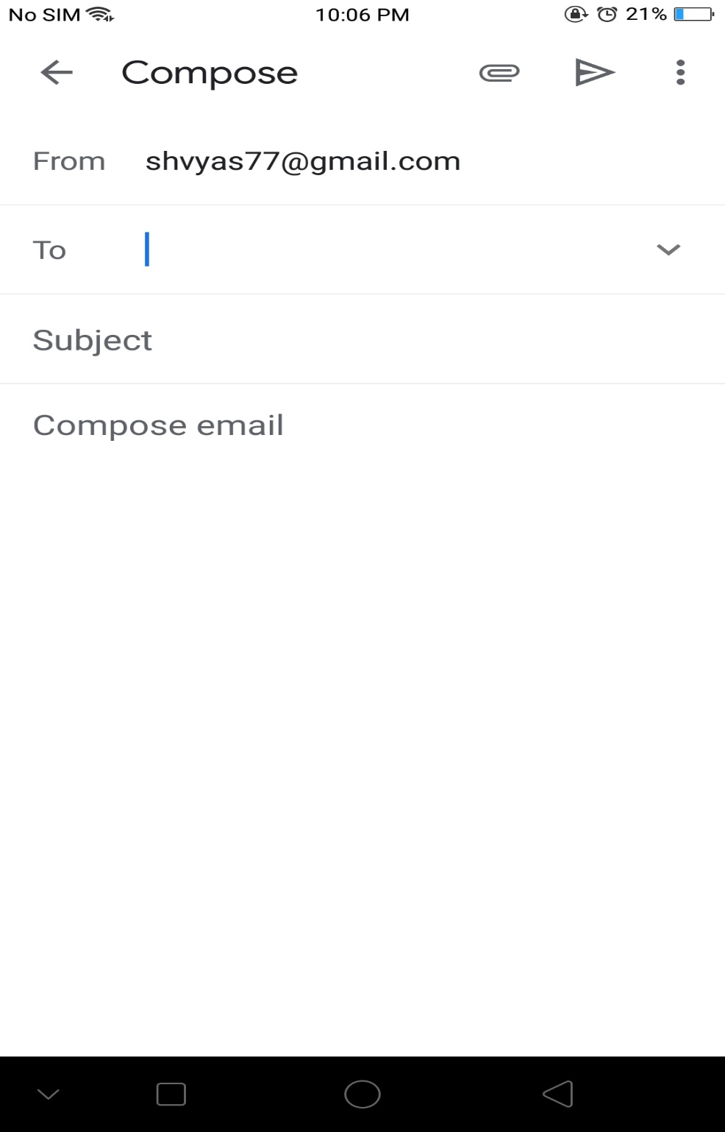**Use proper salutations and introduce yourself**

From- sender email id,To-email id of receiver,Subject-Concissess summary of topic,

Paper pin symbol-Attachments photos document etc,Arrow-Will send the mail.

In bottom mention ENCLOUSER,if attaching any document .

